**Gender Classification**

Artificial Intelligence

CS-E

**Group Members**

**1. 17L-4010 (E)**

**2. 17L-4154 (E)**

**3. 17L-4238 (E)**

**4. 17L-6326 (E)**

**Motivation:** What problem are you tackling and why it is important to solve that problem?

**Ans**: Face is one of the most imperative biometric attributes. Thus, face evaluation can help to gather great information such as gender. Therefore, a successful gender classification can help us boost performance in certain applications such as face recognition, smart computer human-interface, and computer-aided psychological analysis.

To understand information regarding male/female characteristics is an interesting task with an additional benefit of contributing to the community of data science and machine learning. Thus, we feel gender classification is a great motivation to carry forward.

**Method**: What are some of the AI or machine learning techniques/methods you are planning to

Use?

**Ans**: We intend to make gender classifiers using various techniques including Convolutional Neural Networks and decision tree method. We will train our classifiers on various data sets.

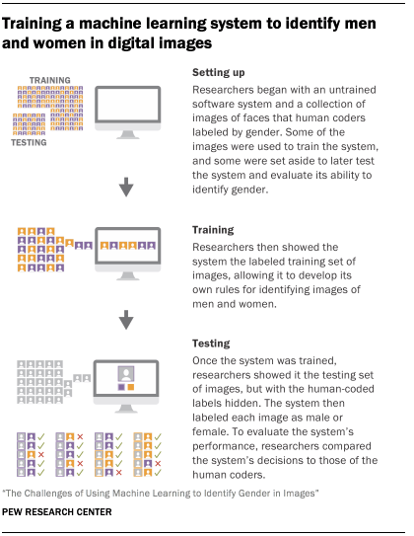

**Experiments**: What are some of the experiments that you intend to perform?

**Ans**: We will apply both the classifiers i.e CNN and Decision Tree on various data sets and will compare the efficiency of both classifiers. Moreover, after finding results we will try to make the classifiers more efficient by any smarter and efficient code snippets.